Date:22-12-2021

**Program - 8**

**Aim:**

Program to implement decision trees using any standard dataset available in the public domain and find the accuracy of the algorithm

**Program:**

import pandas as pd

import numpy as np

import seaborn as sns

import matplotlib.pyplot as plt

from sklearn.preprocessing import LabelEncoder

from sklearn.model_selection import train_test_split

from sklearn.tree import DecisionTreeClassifier

from sklearn.metrics import classification_report,confusion_matrix

from sklearn.tree import plot_tree

df=sns.load_dataset('iris')

print(df.head())

print(df.info())

df.isnull().any()

print(df.shape)

sns.pairplot(data=df,hue='species')

plt.savefig("pne.png")

sns.heatmap(df.corr())

plt.savefig("one.png")

target=df['species']

df1=df.copy()

df1=df1.drop('species',axis=1)

print(df1.shape)

print(df1.head())

x=df1

print(target)

le=LabelEncoder()

target=le.fit_transform(target)

print(target)

y=target

x_train,x_test,y_train,y_test=train_test_split(x,y,test_size=0.2,random_state=42)

print("Training split input",x_train.shape)

print("Testing split input",x_test.shape)

dtree=DecisionTreeClassifier()

dtree.fit(x_train,y_train)

print("Decision tree classifier created")

y_pred=dtree.predict(x_test)

print("classsification report \n",classification_report(y_test,y_pred))

cm=confusion_matrix(y_test,y_pred)

plt.figure(figsize=(5,5))

sns.heatmap(data=cm,linewidth=5,annot=True,square=True,cmap='Blues')

plt.ylabel('Actual label')

plt.xlabel('Predictd label')

all_sample_title='Accuracy Score:{0}'.format(dtree.score(x_test,y_test))

plt.savefig("two.png")

plt.figure(figsize=(20,20))

dec_tree=plot_tree(decision_tree=dtree,feature_names=df1.columns,

class_names=["setosa","vercicikor","verginica"],filled=True,precision=4,rounded=True)

plt.savefig("three.png")

**OUTPUT**

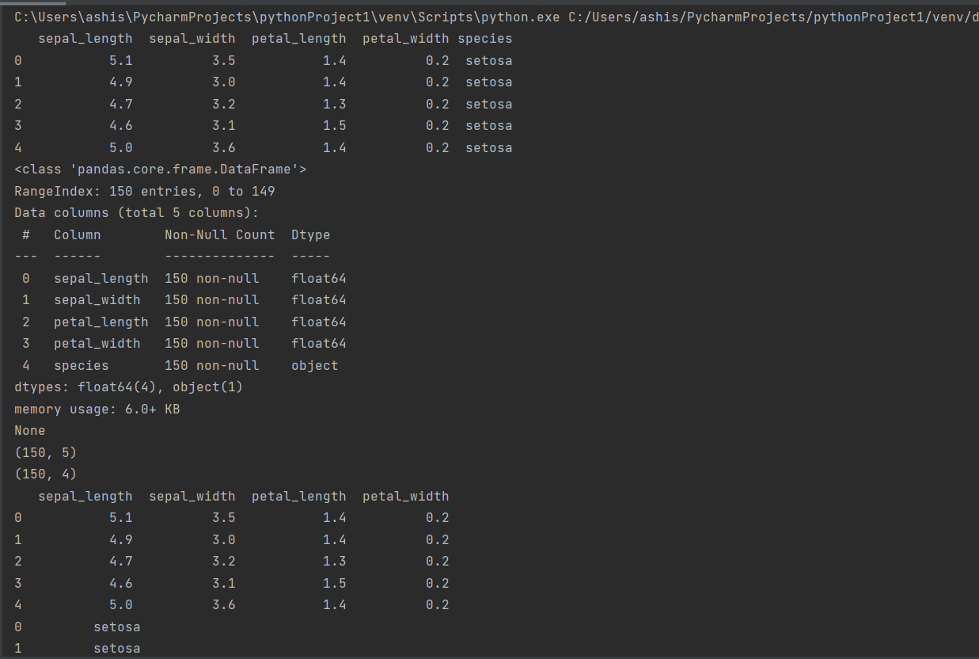

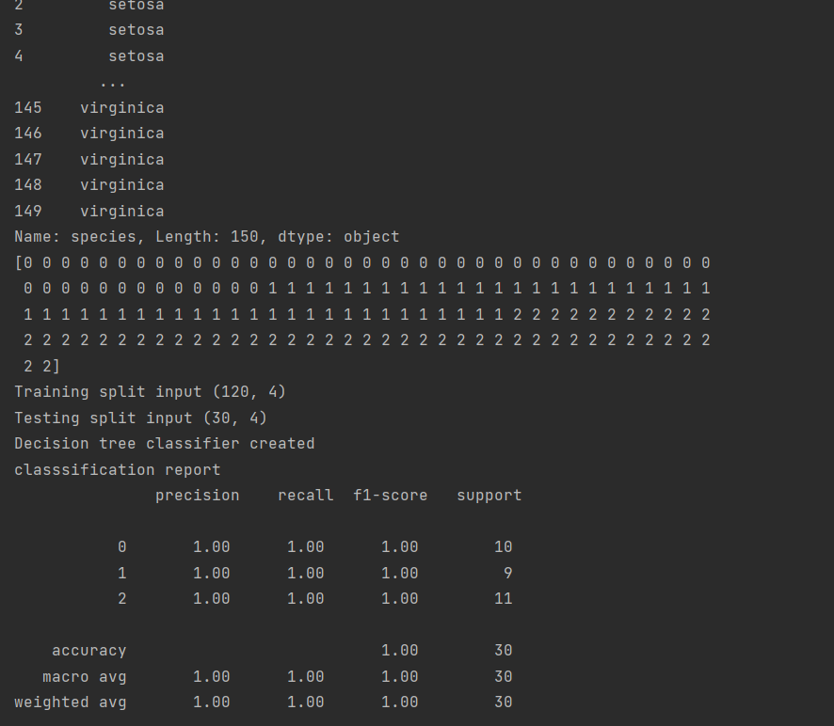

**Pne.png**

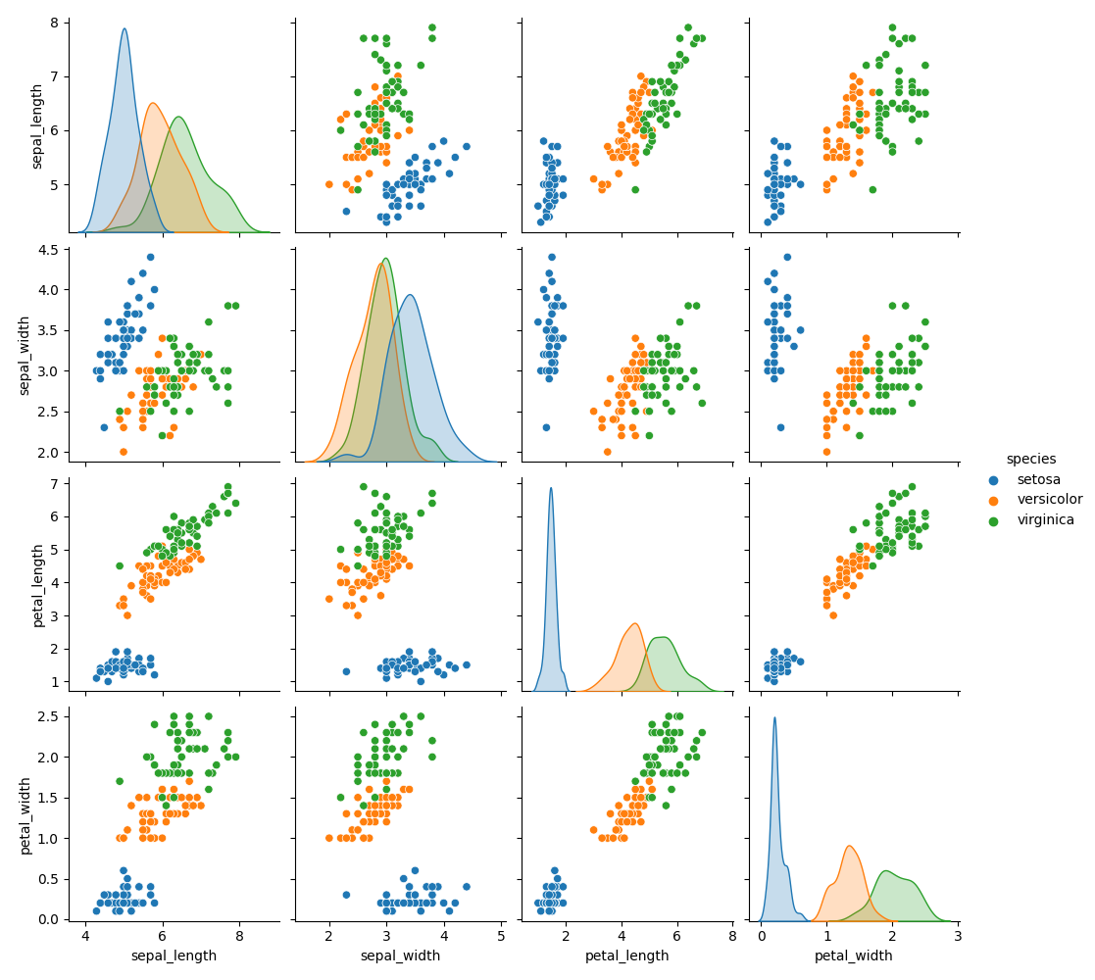

**One.png**

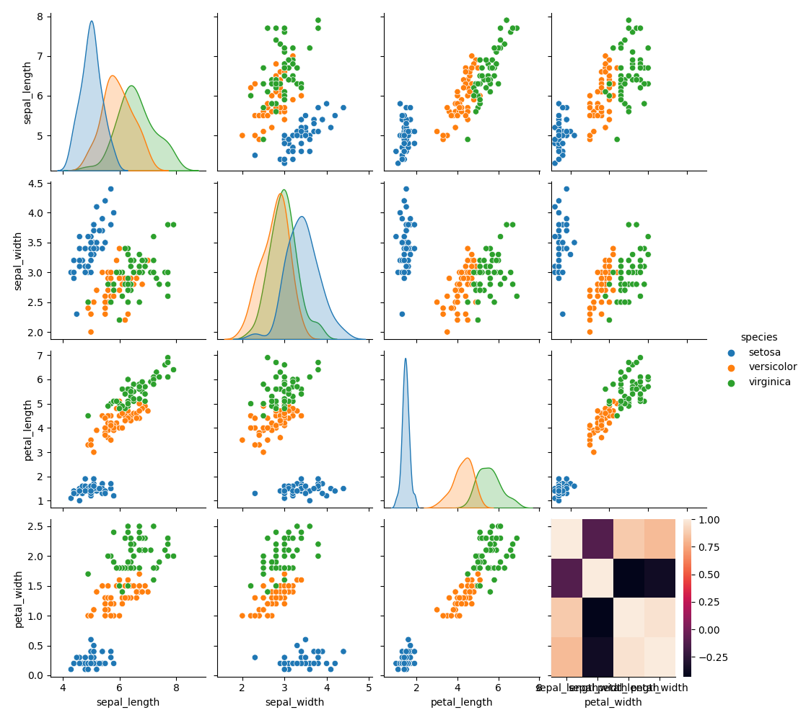

**Two.png**

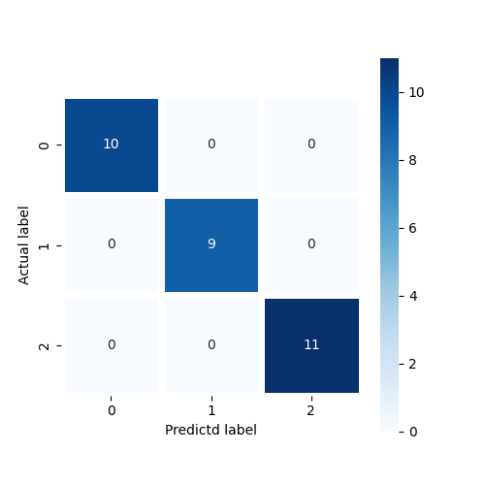

**Three.png**

